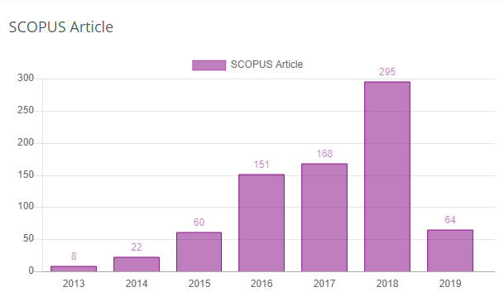

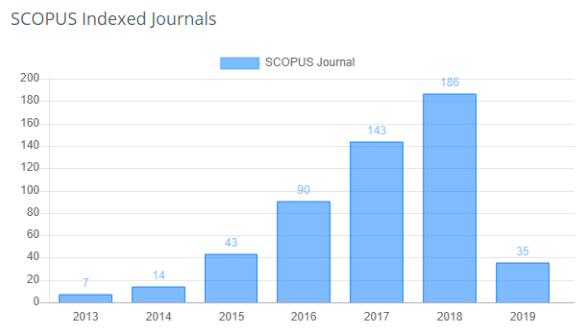

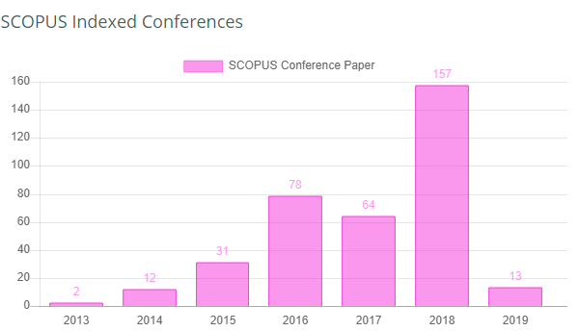

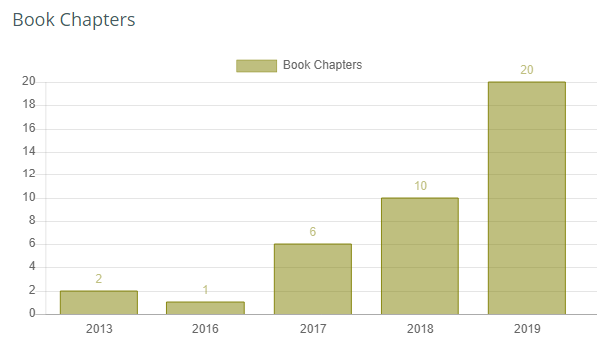

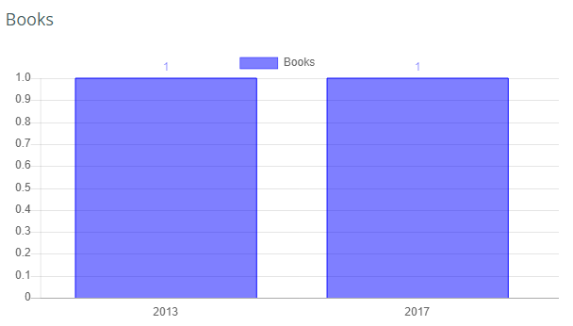

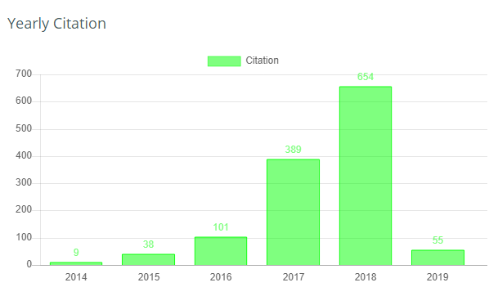

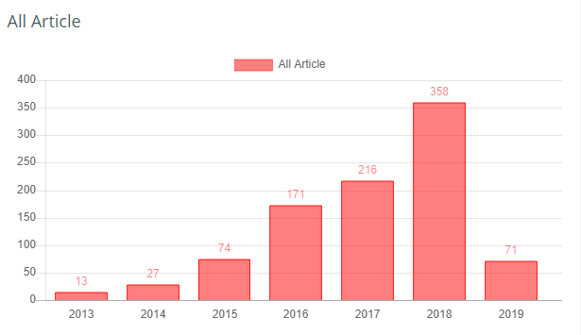

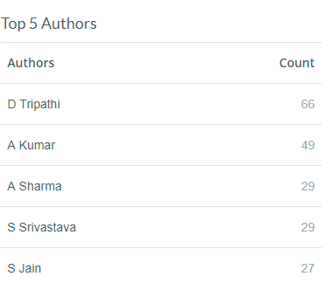

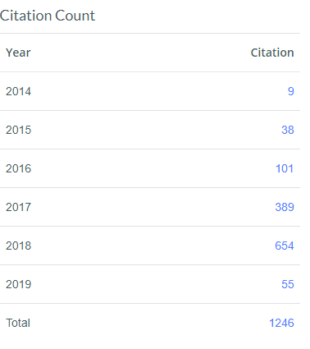

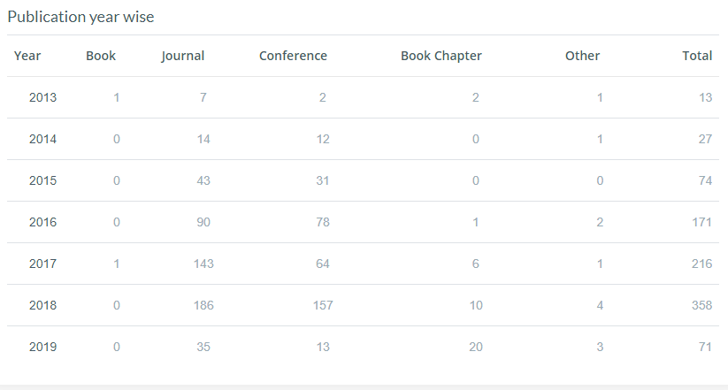

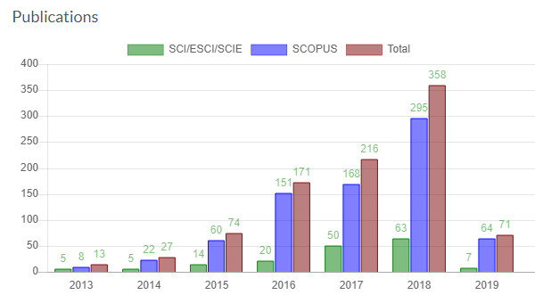

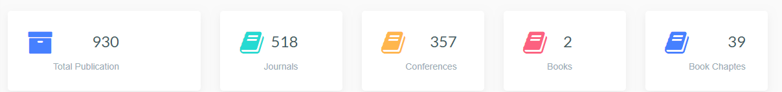

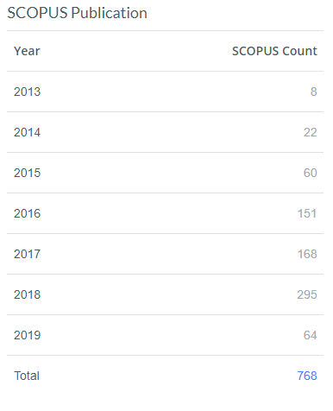

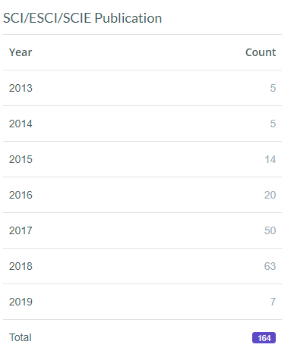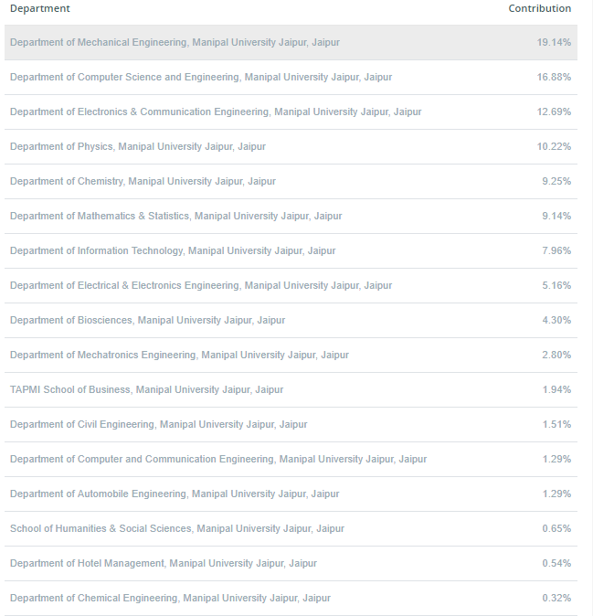

|  |  |
| --- | --- |
| **Department** | **Contribution** |
| [Department of Mechanical Engineering, Manipal University Jaipur, Jaipur](http://pubm.website/RMS/admin/department.php?dept=Department%20of%20Mechanical%20Engineering,%20Manipal%20University%20Jaipur,%20Jaipur) | 19.14% |
| [Department of Computer Science and Engineering, Manipal University Jaipur, Jaipur](http://pubm.website/RMS/admin/department.php?dept=Department%20of%20Computer%20Science%20and%20Engineering,%20Manipal%20University%20Jaipur,%20Jaipur) | 16.88% |
| [Department of Electronics & Communication Engineering, Manipal University Jaipur, Jaipur](http://pubm.website/RMS/admin/department.php?dept=Department%20of%20Electronics%20&%20Communication%20Engineering,%20Manipal%20University%20Jaipur,%20Jaipur) | 12.69% |
| [Department of Physics, Manipal University Jaipur, Jaipur](http://pubm.website/RMS/admin/department.php?dept=Department%20of%20Physics,%20Manipal%20University%20Jaipur,%20Jaipur) | 10.22% |
| [Department of Chemistry, Manipal University Jaipur, Jaipur](http://pubm.website/RMS/admin/department.php?dept=Department%20of%20Chemistry,%20Manipal%20University%20Jaipur,%20Jaipur) | 9.25% |
| [Department of Mathematics & Statistics, Manipal University Jaipur, Jaipur](http://pubm.website/RMS/admin/department.php?dept=Department%20of%20Mathematics%20&%20Statistics,%20Manipal%20University%20Jaipur,%20Jaipur) | 9.14% |
| [Department of Information Technology, Manipal University Jaipur, Jaipur](http://pubm.website/RMS/admin/department.php?dept=Department%20of%20Information%20Technology,%20Manipal%20University%20Jaipur,%20Jaipur) | 7.96% |
| [Department of Electrical & Electronics Engineering, Manipal University Jaipur, Jaipur](http://pubm.website/RMS/admin/department.php?dept=Department%20of%20Electrical%20&%20Electronics%20Engineering,%20Manipal%20University%20Jaipur,%20Jaipur) | 5.16% |
| [Department of Biosciences, Manipal University Jaipur, Jaipur](http://pubm.website/RMS/admin/department.php?dept=Department%20of%20Biosciences,%20Manipal%20University%20Jaipur,%20Jaipur) | 4.30% |
| [Department of Mechatronics Engineering, Manipal University Jaipur, Jaipur](http://pubm.website/RMS/admin/department.php?dept=Department%20of%20Mechatronics%20Engineering,%20Manipal%20University%20Jaipur,%20Jaipur) | 2.80% |
| [TAPMI School of Business, Manipal University Jaipur, Jaipur](http://pubm.website/RMS/admin/department.php?dept=TAPMI%20School%20of%20Business,%20Manipal%20University%20Jaipur,%20Jaipur) | 1.94% |
| [Department of Civil Engineering, Manipal University Jaipur, Jaipur](http://pubm.website/RMS/admin/department.php?dept=Department%20of%20Civil%20Engineering,%20Manipal%20University%20Jaipur,%20Jaipur) | 1.51% |
| [Department of Computer and Communication Engineering, Manipal University Jaipur, Jaipur](http://pubm.website/RMS/admin/department.php?dept=Department%20of%20Computer%20and%20Communication%20Engineering,%20Manipal%20University%20Jaipur,%20Jaipur) | 1.29% |
| [Department of Automobile Engineering, Manipal University Jaipur, Jaipur](http://pubm.website/RMS/admin/department.php?dept=Department%20of%20Automobile%20Engineering,%20Manipal%20University%20Jaipur,%20Jaipur) | 1.29% |
| [School of Humanities & Social Sciences, Manipal University Jaipur, Jaipur](http://pubm.website/RMS/admin/department.php?dept=%20School%20of%20Humanities%20&%20Social%20Sciences,%20Manipal%20University%20Jaipur,%20Jaipur) | 0.65% |
| [Department of Hotel Management, Manipal University Jaipur, Jaipur](http://pubm.website/RMS/admin/department.php?dept=Department%20of%20Hotel%20Management,%20Manipal%20University%20Jaipur,%20Jaipur) | 0.54% |
| [Department of Chemical Engineering, Manipal University Jaipur, Jaipur](http://pubm.website/RMS/admin/department.php?dept=Department%20of%20Chemical%20Engineering,%20Manipal%20University%20Jaipur,%20Jaipur) | 0.32% |
| [School of Architecture & Design, Manipal University Jaipur, Jaipur](http://pubm.website/RMS/admin/department.php?dept=School%20of%20Architecture%20&%20Design,%20Manipal%20University%20Jaipur,%20Jaipur) | 0.32% |
| [Department of Commerce, Manipal University Jaipur, Jaipur](http://pubm.website/RMS/admin/department.php?dept=%20Department%20of%20Commerce,%20Manipal%20University%20Jaipur,%20Jaipur) | 0.22% |
| [Department of Journalism & Mass Communication, Manipal University Jaipur, Jaipur](http://pubm.website/RMS/admin/department.php?dept=Department%20of%20Journalism%20&%20Mass%20Communication,%20Manipal%20University%20Jaipur,%20Jaipur) | 0.22% |
| [Department of Planning, Manipal University Jaipur, Jaipur](http://pubm.website/RMS/admin/department.php?dept=Department%20of%20Planning,%20Manipal%20University%20Jaipur,%20Jaipur) | 0.22% |
| [Department of Business Administration, Manipal University Jaipur, Jaipur](http://pubm.website/RMS/admin/department.php?dept=Department%20of%20Business%20Administration,%20Manipal%20University%20Jaipur,%20Jaipur) | 0.11% |

